Previous Research Experience Mandy Slate

My undergraduate research experiences commenced during my sophomore year when I transferred to Portland State University (PSU). My biology professor from the local community college suggested that I contact Dr. Sarah Eppley at PSU, and this grew into a three year relationship that defined much of my academic and professional career. Initially, having over ten years of horticultural experience, I assumed responsibility for propagation and maintenance in the two bryophyte research greenhouses at PSU. Over the following three years, I trained three undergraduate women to assist and then take over this large endeavor. From this experience, I gained an understanding of the interactions between bryophyte physiology and ecology, two components integral to plant community interactions.

Six months later in a scanning electron microscopy (SEM) class, I encountered the perfect opportunity for my first research project. Collaborating with a graduate student in my lab, I worked to develop specimen preparation techniques for imaging moss sperm on microarthropods using SEM. Fine attention to detail and collaboration with experts in electron microscopy nationwide helped me improve the resolution at which we can now visualize these minute associations. Results indicating insect-assisted fertilization of bryophytes could lead to a re-evaluation of previous hypotheses regarding the evolution of pollinators, which is thought to have arisen simultaneously with the angiosperms1. This project culminated in a presentation during a SEM research symposium at Portland State University in the fall of 2010.

In January of 2011, I applied for and received a PSU undergraduate research grant to develop methods for testing nutrient pulse-releases from bryophytes following rehydration events. Mosses are unusual ecosystem engineers; affecting both the plants around them as well as the microbial communities below2 (see Figure 1). Bryophytes differ from tracheophytes by: not having roots, expressing different biochemistry, being poikilohydric, controlling soil chemistry by nutrient absorption and buffering, altering ecosystem hydrology and regulating soil temperatures3. Research also suggests that bryophytes may release disproportionately large quantities of inter-cellular solutes when their cell walls break during rehydration. The ecological implications of rehydration-induced nutrient release from bryophytes are substantial; carbohydrates, amino acids and cations are released during the rehydration period3,4. Quantifying and identifying the nutrients released from such fundamentally different organisms during this critical time period will assist in our understanding of the fate of these nutrients and which organisms they may be affecting. I have developed collection systems and sampling methods for catching bryophyte rehydration leachates. By collaborating with Dr. Sarah Eppley, Dr. Todd Rosenstiel and a graduate student in their lab, I gained mastery of both an elemental analyzer and a total organic carbon liquid analyzer to measure the carbon and nitrogen components of bryophytes and rehydration leachates (see Proposed Research). I presented these protocols at the McNair Research Conference held at PSU in the spring of 2011. These methods are at the crux of my graduate research and will be directly applicable in the next few months as analyses progress.

I was hired by the Eppley and Rosenstiel labs, at PSU, as a full-time research assistant in June of 2011. During the next year, I investigated intersexual variation of physiological and morphological characters and natural sex-ratios of the unisexual moss *Ceratodon purpureus*. From measuring traits such as: cell wall width, cells per area, leaf area index, and canopy density, I developed a proficiency at microscopy. I also developed a familiarity with methods used to quantify community composition and structure. Identifying physiological differences in separate-gender mosses contributes to our understanding of the underlying mechanisms that drive reproductive biology in bryophytes. By adding this understudied component to the bryological literature, I have helped refine our predictive accuracy in studies involving unisexual bryophytes. My findings regarding sex-specific physiology resulted in two national presentations and a publication currently in progress. This experience also provided an incredible opportunity to draw in and work with undergraduates interested in gaining research experiences. The mentees with which I had the pleasure of working are now engaged in their own research projects as they continue to pursue their love of science.

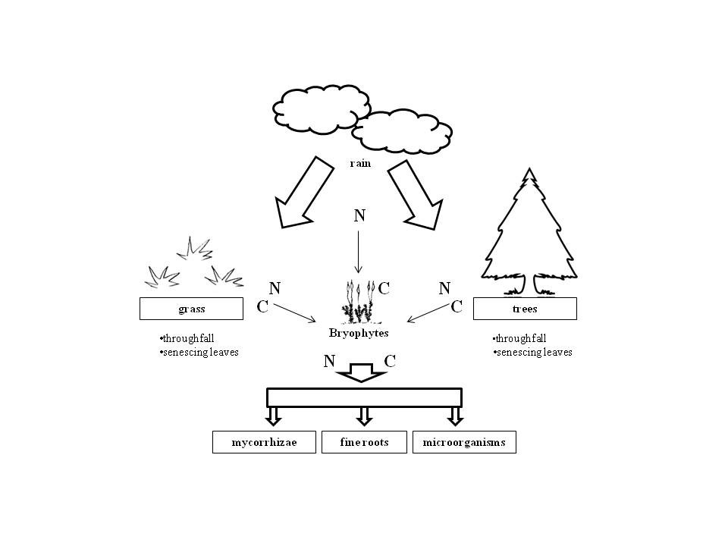

**Nutrient Cycling and Bryophytes**

Figure 1: Conceptual diagram displaying intricate relationships between bryophytes, tracheophytes, and soil dwelling organisms. N=nitrogen, C=carbon (2)

The University of Montana (UM) has recently presented me with an outstanding educational opportunity. I am fortunate to be working with Dr. Ragan Callaway, a community ecologist and Dr. Anna Sala, an ecophysiologist. I am also consulting with Dr. Cory Cleveland, an expert in nutrient cycling, to add proficiency in below-ground ecology. The combined expertise and guidance of these mentors is allowing me to move from the cellular level to the ecosystem level within my study system and will help me assign mechanisms to large scale biogeochemical interactions. I am in the initial stages of organizing an inter-departmental collaborative project between graduate students in three departments at UM. I feel that these sorts of associations are critical to increase the quality, impact, dissemination, and implementation of our research. I will be teaching two classes within the next year in conjunction with two local non­profit organizations, which will permit me to better disseminate an awareness of these overlooked components of our ecosystems.

Based on my previous research on bryophyte rehydration leachates at PSU in conjunction with findings from a literature review I am currently conducting, I believe that the bryophyte component of ecosystem relationships has been understudied. I hope that my research in this area will inspire a re-evaluation of the synergistic role of mosses in our ecosystems, and demonstrate the many ecosystem functions which bryophytes provide to society that are much different from those of vascular plants.

My undergraduate and post-baccalaureate research experiences endowed me with a clear research focus while implanting a strong foundational knowledge base from which my graduate studies can now draw. Embarking on my graduate career at the University of Montana, I am finally face to face with opportunities which were previously only a glimmer on my professional horizon. A NSF GRFP will help me achieve my goals as I continue down the path towards a career as a plant ecophysiologist. ________________________________________________________________________

1) **Rosenstiel** T et al. (2012) Nature 486:431-436. 2) **Cornelissen** J et al. (2007) Annals of Botany 99:987-1001.

3) **Glime** J (2007) Bryophyte Ecology. (Ebook). 4) **Alpert** P (1982) Poikilohydry and desiccation tolerance in some

xerophytic mosses. Doctor of Philosophy (Harvard University, Cambridge).